FACULTY PROFILE

# Personal Information:

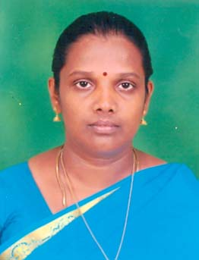OTO

**Name:** Dr.P.Krishnaveni

# Designation/Position: AP(SG)

# Department: Department of Computer Science and Engineering

# Email: krishnaveni@pmu.edu

# Phone Number: 9245218300

# Office Address: First Floor, PKC

**Educational Background:**

|  |  |  |  |  |
| --- | --- | --- | --- | --- |
| **Degree** | **Major/Field** | **Institution** | **University** | **Year of Graduation** |
| PhD | Computer Applications | NIT, Trichy | NIT, Trichy | 2021 |
| M.E., | CSE | GCE, Tirunelveli | Anna University | 2005 |
| B.E., | CSE | PMCTW, Vallam | Bharathidasan University | 1997 |

**Research Interests:**

* Natural language processing, Data Mining, Data Science, AI and ML.

**Teaching Interests:**

* Data Structures, Algorithms, Operating Systems, Theory of Computation, Compiler Design, Problem Solving and Python Programing, C Programing, Foundations of Data Science, AI &ML, Object Oriented Programming.

**Publications:**

# JournalArticles:

1. **Krishnaveni, P and S. R. Balasundaram.** Automatic Text Summarization by Providing Coverage, Non-redundancy, and Novelty using Sentence Graph. *Journal of Information Technology Research*, Vol 15, No. 1, 2022. **(Web of Science-ESCI).** DOI: 10.4018/JITR.2022010108

**2. Krishnaveni, P and S. R. Balasundaram.** Summarizing Learning Materials using Graph Based Multi-document Summarization*. International Journal of Web-Based Learning and Teaching Technologies*, Vol 16, No. 5, 2021. **(IGI-Global-SCOPUS).** DOI: 10.4018/IJWLTT.20210901.oa3

**3. Krishnaveni, P and S. R. Balasundaram.** Generating Fuzzy Graph Based Multi-document Summary of Text Based Learning Materials. *Expert Systems with Applications,* Vol 214, p.119165, 2023. **(Elsevere Journal-SCIE).** DOI: 10.4018/IJWLTT.20210901.oa3

# Conference Papers:

1. **Krishnaveni, P**. **and Balasundaram, S.R.** Automatic Text Summarization by Local Scoring and Ranking for Improving Coherence. *Proceedings of the IEEE 2017 International Conference on Computing Methodologies and Communication* (ICCMC), Erode, Tamilnadu, July 18-19, 2017.

**2.Krishnaveni, P**. **and Balasundaram, S.R*.*** Learning Materials Summarization using Fuzzy Graph*. Proceedings of the Springer 2021 6th International Conference on Nano-electronics, Circuits & Communication Systems* ***(NCCS-2020)*, Ranchi, India, December 19-20, 2020.(IN Press)**

**3.Krishnaveni, P**. **and Balasundaram, S.R*.*** Fuzzy Logic Based Query Focused Learning materials summarization*. Abstracts of the 17th International Conference AsiaCALL2021 & VLTESOL*, Van Lang University, Vietnam, January 22-23, 2021.

# Professional Experience:

|  |  |  |  |  |
| --- | --- | --- | --- | --- |
| **Position** | **Institution/Organization** | | **Duration** | |
| Associate Professor | | PITS, Thanjavur | 19-09-2022 To | 29-12-2023 |
| Assistant Professor | | PRCET, Vallam,Thanjavur | 22-06-2010 To | 30-04-2015 |
| Assistant Professor | | PREC, Vallam,Thanjavur | 22-06-2005 To | 21-06-2010 |

**Professional Memberships:**

|  |  |
| --- | --- |
| **PROFESSIONAL BODY** | **TYPE OF MEMBERSHIP** |
| ISTE | Life Membership |
| IAENG | Life Membership |

# Community and University Service:

* Member of Board of Studies of CSE Department of PRIST University (2011-2015).
* Head of the Department of PRCET, Vallam, Thanjavur (2011-2015).
* NAAN Muthalvan Course Instructor for Big Data Analytics and AI and ML, PITS, Thanjavur (2022-2023).

# Languages Known:

* Tamil & English

**Hobbies / Interests:**

* Reading Books, Gardening, and Watching TV.

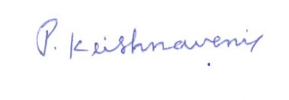

Signature